

VistA Blood Establishment Computer Software (VBECS) 2.0.0

Template Creation Guide

September 2014

Department of Veterans Affairs
Product Development

This page intentionally left blank.

Revision History
Date | Revision | Description | Author
04-09-13 | 1.0 | Initial Version | BBM Team
05-09-13 | 2.0 | Global: Changed “wordpad” to “WordPad”. Corrected the template names throughout the document including in figures.  Create Server Templates from the Base Template section: Updated Step 3 by removing “build” and changing “SQL Server build 1.0” to “SQL Server 1.0, VBECS 2.0.0”.  Figure 4 caption: Changed “Tempate” to “Template”.  Customize the App Server: Added Copy Printer Drivers, Install HHActiveX DLL, Update the PowerShell Execution Policy, Enable ActiveX Controls, Copy NAnt Files and Update Audio Files sub-sections.  Turn the VM into a Template, Step 68: Changed “APP Server build 1.0” to “APP Server 1.0, VBECS 2.0.0”.  Customize the SQL Server: Removed the existing Step 5, since it was redundant with Step 1, Deleted the section that detailed adding a second NIC, renamed the Disable port 25 section.  Appendix A, Step 1: Changed “Vitual” to “Virtual”.  Appendix A, Step 14: Changed “Esport” to “Export”. | BBM Team
12-02-13 | 3.0 | Global: Changed version of templates to VBECS 2.0.0.3  Introduction: Added a reference to the Creating a Virtual Machine Template work instruction.  Added a section called Install Fonts (DR 4819).  Changed so that the user must use to create the template.  Moved template naming instructions from the tracking log to Appendix A.  Added instructions for exporting templates to E:\VBECS Virtual Machine Templates folder. (DR 4802)  Updated screen captures to reflect new naming convention.  Permissions section: Added.  Delete Microsoft XPS Printer section: Added.  Windows Services section: Added.  Create Error Files section: Added.  Add .NET Framework Version 3.5 section: Added. | BBM Team
05-27-14  (continued on next page)  05-27-14  (continued from previous page) | 4.0  4.0 | Global: Changed “2.0.0.3” to “2.0.0.4”.  Customize the App Server:  Removed Enable ActiveX Controls section.  Removed SMTP installation section.  Create a Validation Directory section: Step 1, changed step 9 to step 12.  Add .NET Framework section: Step 8, removed framework folder. Step 9, added detail.  Install HHActiveX DLL section: Step 12, added dll extension.  Install Fonts section: Step 13, added fonts directory.  Update Audio Files section: Step 26, added a note about Trusted Installer.  Install Remote Desktop section: Mentioned the reboot. Deleted text about antivirus instructions.  Add a Second Drive section: Rewrote section.  Permissions section: Updated to reflect that service IDs will be added post installation. Deleted the creation of apatosaurus ID since this is done in the template.  Delete Microsoft XPS printer section: Added more detailed instructions.  Create Error Files section: Moved to after the Install VBECS section.  Event Source Register Tool section: Rewrote.  Added the following sections: Event Source Register Tool, Turn Off ClearType and Create Folders and Assign Permissions.  Added instructions for adding a second processor.  Customize the SQL Server:  Add Users and Groups section: Changed group to HinesVbecsProdSqlSupport.  Revised Step 6 under Create a Validation Directory and Document to Record Screen Captures section.  Add .NET Framework Version 4.0 section: Eliminated framework folder. Deleted Windows Update step.  Apply Hotfixes section: Noted that hotfixes folder has to be created.  Added new sections: Apply AITC Fixes and KB2645410 sections.  Revised Copy Installation Support Files section.  Appendix A:  Reworded the prerequisite.  Added steps to join the domain. | BBM Team  BBM Team
06-09-14 | 5.0 | Customize the App Server:  Added new sections: Install Audio Support (KB2495012) and Disable VBECS Services.  Install Fonts section: Changed folder name from “Arial Fonts” to “Fonts”.  Create Error Files section: Corrected the path names.  Create a Validation Directory section: Removed. | BBM Team
06-27-14 | 6.0 | Customize the App Server, added new section: Disable Windows Defender.  Customize the SQL Server, Copy SQL Fixes section, Step 27: Replaced all updates with SQLServer2012SP2-KB2958429-x64-ENU.  Appendix A: Updated Step 1 by changing “Template Naming Conventions section of the log” to “Appendix A: Update a Template” | BBM Team
09/15/14  09-15-14 | 7.0 (continued on next page)  7.0 (continued from previous page) | Global:  Updated document for the vSphere Web Client.  Removed all references to the installer ID after it is removed in each section.  App and SQL Server sections:  Added the following sections: Adjust the Hard Drive, Configure IDs, Update the Registry for Security Issues, Rename and Adjust NICs, Install and Configure SNMP, Install Security Update for .NET Framework 3.5.1 (KB2898851) and Install SCCM.  App Server section:  Added the following sections: Add .NET Framework Version 3.5, Install Client Tools to App Server.  Added installation of Attachmate Reflection  SQL Server section:  Added: Install Security Update for .NET Framework 4.0 (KB2938780)  Added Appendix B for NIC and hard drive settings.  (DR 5060) | BBM Team  BBM Team

This page intentionally left blank.

Table of Contents

Revision History 3
Introduction 9
Prerequisites 9
Create the Server Templates 11
1 Create Server Templates from the Base Template 11
2 Customize the App Server 15
3 Customize the SQL Server 24
Appendix A: Update a Template 29
Appendix B: Updating NIC and Hard Drive Settings 35
Index 38

This page intentionally left blank.

Introduction
This guide details the creation of the templates for the VBECS 2.0.0 system. It contains instructions for both the App and SQL Server. Creating the templates is a task that only needs to be executed once.
It will also be necessary to update the templates. Appendix A: Update a Template contains instructions for turning the templates into live Virtual Machines (VMs), where they can be updated and then changed back to a template.
Before executing this guide, the Creating a Virtual Machine Template work instruction must be executed to create the base template from which the VBECS templates will be created.

Prerequisites
The following tasks must have been completed before creating either template:
- The base template, Windows Enterprise Server 2008 R2 (x64), must have been created using the Creating a Virtual Machine Template work instruction (WI).
- The template creator must have administrative access to the vSphere environment. Administrator access is granted by adding your normal user id (NMEA ID will not work) to the HinesVBECSVMwareAdmins group in active directory.
This page intentionally left blank.

Create the Server Templates
These instructions detail the process for creating the server templates. These steps apply to both the App and SQL Servers and must be executed by a vSphere administrator.

Create Server Templates from the Base Template

Prerequisite
Except when noted, these instructions must be executed from the vSphere Web Client. Navigate to https://IPADDRESS :9443 in the browser and login with your normal (not NMEA) account. If you are warned about a security certificate, proceed to the site.
- Select VMs and Templates to open the VMs and Templates view (Figure 1).
Figure 1: Example of vSphere Client
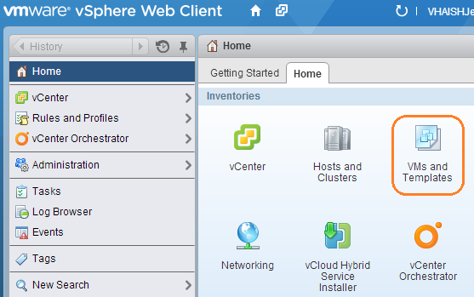
- In the Templates folder, right-click on the Windows Enterprise Server 2008 R2 (x64) template and click Clone to Template (Figure 2).
Figure 2: Example of Template Folder
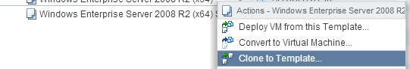
- Enter VBECS 2.n.n.n App Server n.n (if creating the SQL template, enter VBECS 2.n.n.n SQL Server n.n) for the template name (Consult the VBECS 2.0.0 Virtual Machine Template Device Master Index to determine the name of the template). Select the Templates folder (Figure 3). Click Next.
Figure 3: Example of Clone Template To Template
Image Redacted
- Expand VBECSCluster and select the IPADDRESS host (Figure 4). Click Next.
Figure 4: Example of Clone Template To Template
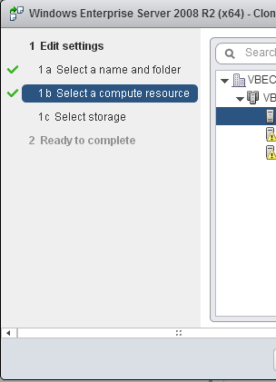
- Change virtual disk format to Thin Provision (Figure 5). Click Next.
Figure 5: Example of Clone Template To Template
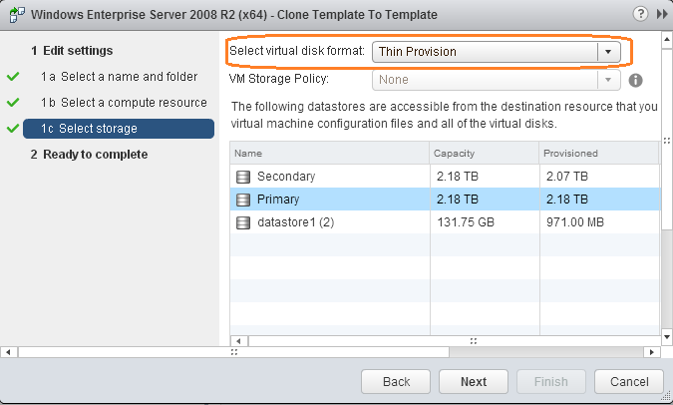

- Click Finish (Figure 6).
Figure 6: Example of Clone Template To Template
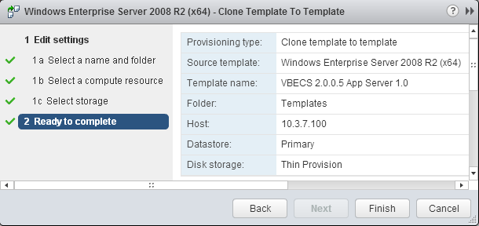

Customize the App Server

Prerequisite
These instructions are for customizing the App Server. If customizing the SQL Server, go to Customize the SQL Server.
- Execute Steps 1 through 9 from Appendix A: Update a Template to turn the App Server template into a VM and note the IP address. After you have the IP, remote into the App Server using the local administrator account.

App Server Template Configuration
Follow these steps to configure Windows and software settings.

Disable User Access Control
- Login to the App Server with the Administrator ID.
- Click Start. In the search field, enter UAC.
- Click Change User Account Control Settings.
- Drag the slider down to Never notify. Click OK (Figure 7). Click Yes on the confirmation window that follows.
Figure 7: User Account Control Settings

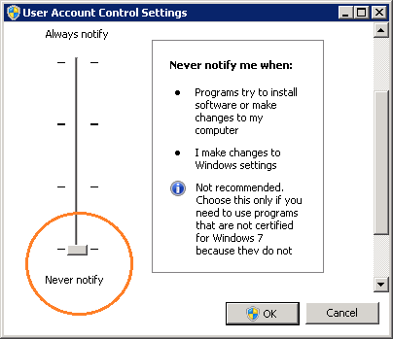

Adjust the hard drive
- Open Administrative Tools, Computer Management, Disk Management.
- Right-click on the C: drive and choose Extend Volume.
- Click Next.
- Click Next.
- Click Finish. The C: drive will now have a capacity of 79.90 GB. Leave Computer Management open for the next step.

Configure IDs
- Open Administrative Tools, Computer Management.
- Expand Local Users and Groups and select the Users folder.
- Right-click on the apatosaurus ID and choose Delete. Click Yes to confirm. Click OK on the second confirmation.
- Right-click on the installer ID and choose Delete. Click Yes to confirm. Click Yes to confirm. Click OK on the second confirmation.
- Right-click on the Administrator ID and choose Rename.
- Rename the ID vaaacnimda and close Computer Management. From this point on, remember to log into the App Server Template with the vaaacnimda id instead of Administrator.
Update the PowerShell Execution Policy
- Launch PowerShell (x64) by clicking the icon () in the Task Bar.
- Run the following command: set-executionpolicy unrestricted.
- When prompted, enter Y. Close the window.
- Click Start and in the Search programs and files search, type Windows PowerShell (x86) and press Enter.
- Run the following command: set-executionpolicy unrestricted.
- When prompted, enter Y. Close the window.

Update Audio Files
- In Windows Explorer, navigate to c:\Windows\Media.
- Rename the Windows Exclamation.wav file Windows Critical Stop.wav and vice versa. Add permissions from Trusted Installer if prompted.

Enable Port 25
- Click Start, All Programs, McAfee, VirusScan Console.
- Double-click Access Protection.
- Select Anti-virus Standard Protection.
- Deselect Prevent mass-mailing worms from sending mail in both the Block and Report categories.

Update the Registry for Security Issues
- At the run prompt, type regedit and click OK.
- Navigate to HKEY_LOCAL_MACHINE\SYSTEM\CurrentControlSet\services\ac.sharedstore.
- Double-click on ImagePath.
- Put double quotes around the Value data so the entry looks like this: “C:\Program Files\Common Files\ActivIdentity\ac.sharedstore.exe”
- Click OK to save.
- Navigate to HKEY_LOCAL_MACHINE\SYSTEM\CurrentControlSet\Control\Session Manager.
- Right-click on Session Manager and select New, DWORD (32-bit) Value.
- Name the new value CWDIllegalInDllSearch.
- Right-click and select Modify.
- Enter 1 and click OK to save. Close the Registry Editor.

Rename and Adjust NICs
- Open Control Panel, Network and Internet, Network and Sharing Center, Change Adapter Settings.
- Rename Local Area Connection #2 GSS and Local Area Connection #3 Backup.
- Right-click on the Backup NIC and choose Properties.
- Uncheck everything except for IPv4 and IPv6. Click OK.
- Right-click on the Backup NIC and choose Properties, Configure, Advanced tab.
- There are four Checksum Offload properties, two for IPv4 and two for IPv6. Disable them all. Click OK to save and close the network configuration windows.

Add a Second Drive
- In the vSphere Web Client, right-click the template and select Edit Settings.
- In the New device control, select New Hard Disk.
- Click Add.
- In the Hardware tab, click Add.
- Change the disk size to 10 GB and provision as thin (Thin provision setting).
- Click OK to save. Restart the App Server.
- Login to the App Server with the local Administrator ID.
- Launch the command prompt.
- Type diskpart and press Enter.
- Type select disk 1 and press Enter.
- Type attributes disk clear readonly and press Enter.
- Type online disk and press Enter.
- Click Start, Administrative Tools, Computer Management, Disk Management.
- The Initialize Disk dialog automatically launches. (If it doesn’t launch, right-click and choose Bring Online. Then, right-click and choose Initialize.) Click OK.
- Right-click on the disk and choose New Simple Volume.
- In the Welcome window, click Next.
- In the Specify Volume Size window, click Next.
- In the Assign Drive Letter or Path window, click Next.
- In the Format Partition window, change the Volume label to Reports. Click Next.
- Click Finish to create the drive and close the window.

Permissions
- Open Control Panel, System and Security, System.
- Click Change settings.
- Click Change.
- Enter VBECSAPPTMPLATE for the computer name.
- Select the domain radio button and enter vha.domain.ext. Click OK. Restart to join the domain.
- Navigate to Administrative Tools, Computer Management, Local Users and Groups, Groups.
- Open the local Administrators group.
- Add the group. The service IDs will be manually added post-installation. Close the Window.
Turn Off ClearType
- Click Start.
- In the Search programs and files text box, enter clear type.
- Click on Adjust ClearType text. The ClearType Text Tuner window launches.
- Deselect Turn on ClearType.
- Click Next 5 times and then Finish.
Create Folders and Assign Permissions
- Navigate to D:\ and create the following folders:
- VBECSReports
- Prod Logs
- Test Logs
For the Prod Logs and Test Logs folders, grant the permissions detailed in Figure 8 to the Everyone group. Note that the Read permission (cannot be seen in figure) should also be Allowed.
Figure 8: Permissions
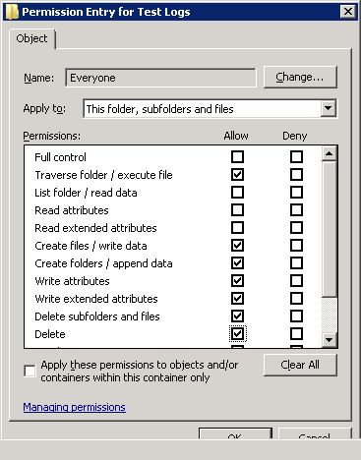

Delete Microsoft XPS printer
- Open Devices and Printers and delete the Microsoft XPS Document Writer printer (right-click and select Remove Device).

Windows Services
- Open Services and set the Startup Type on the Windows Audio service to Automatic.

Software Installation
Follow these configuration steps to install software.

Install and Configure SNMP
- Open Server Manager and click Features, Add Features.
- Select SNMP Services which will automatically select the two sub features. Click Next.
- Click Install.
- Click Close.
- Copy the \\\CDimages\_software\_VBECS 2.0\Both\SNMP scripts folder to C:\temp.
- Launch PowerShell (x64) by clicking the icon () in the Task Bar.
- Run the following command: “c:\temp\SNMP script\supdatesnmp”
- Close the PowerShell console.
- In c:\temp\SNMP scripts, double-click SNMP-config to run the registry edit.
- A warning will appear, click Yes followed by OK on the confirmation message.

Install Audio Support (KB2495012)
- Open Server Manager and click Features, Add Features.
- Select Desktop Experience.
- The Add Features Wizard launches. Click Add Required Features.
- Click Next.
- Click Install.
- Click Close and restart the server when prompted.
- The server will take a bit longer than usual to restart. Once it restarts and you log back in, the installation will continue. You will see a Resume Configuration Wizard. When complete, click Close.
- Open a command prompt and type: sc config beep start= auto (Figure 9). Press Enter.
Figure 9: Beep Service Configuration
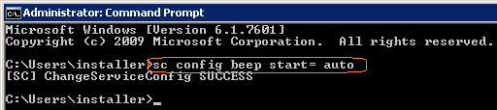
- Click Start, Administrative Tools, Task Scheduler. The Task Scheduler launches.
- Navigate to Task Scheduler Library, Microsoft, Windows, Multimedia. Right-click on SystemSoundService and select Enable.
- Close the Task Scheduler.

Disable and Delete Windows Defender Service
- Navigate to Control Panel and open Windows Defender.
- Click Tools, Options.
- In the left pane, click Administrator. In the right pane, uncheck Use this program. Click Save.
- You will see a window confirming that Windows Defender is turned off. Click Close.
- Close Control Panel.
- Navigate to Administrative Tools and open the Services.
- Right-click on Windows Defender and click Properties.
- Change the Startup type to Disabled. Click OK.
- Close the Services console and Administrative Tools.
- Open a command prompt and type sc delete windefend (Figure 10). Press Enter.
Figure 10: Delete Windows Defender
Image Redacted

Copy Printer Drivers
- The printer drivers are located on the \\\CDimages\_software\_VBECS 2.0\App Server\share. Copy the HP9040 PCL6 Driver folder to C:\temp\.

Add .NET Framework Version 3.5
- Open Server Manager and click Features, Add Features.
- Select .NET Framework 3.5.1 Features.
- The Add Features Wizard launches. Click Add Required Role Services.
- Click Next.
- Click Next.
- Click Next.
- Click Install.
- Click Close when complete.

Add .NET Framework Version 4.5
- Copy the \\\CDimages\_software\_VBECS 2.0\App Server\4.5 Framework folder to c:\temp\ and install.
- After installation is complete, reapply all critical Windows Updates. Do not install any new versions of Internet Explorer.

Install Security Update for .NET Framework 4 (KB2898851)
- Copy the \\\CDimages\_software\_VBECS 2.0\Both\KB2898851 folder to C:\temp.
- Double-click on Windows6.0-KB2898851-x64 to start the installation.
- Click Yes to proceed with the installation.
- Click Close.

Install SQL Client Tools
- Copy the \\\CDimages\_software\_VBECS 2.0\App Server\SQLCMD folder to c:\temp\.
- Double-click sqlncli to start the installation.
- Click Next.
- Accept the license and click Next.
- Click Next.
- Click Install.
- Click Finish.
- Double-click SqlCmdLnUtils to start the installation.
- Click Next.
- Accept the license and click Next.
- Click Install.
- Click Finish.

Install Attachmate Reflection
- Copy the \\\CDimages\_software\Attachmate folder to c:\temp\.
- Double-click on Reflection1404BaseInstall.bat to install.

Install Hotfix for Report Support
- Copy the \\\CDimages\_software\_VBECS 2.0\App Server\Report Hotfix folder to c:\temp and install.

Install HHActiveX DLL
- Copy the \\\CDimages\_software\_VBECS 2.0\App Server\ folder to c:\Windows\ SysWOW64.
- Open a command prompt and execute the following command: regsvr32 c:\Windows\SysWOW64\HHActiveX\HHActiveX.dll

Install Fonts
- The fonts for VBECS are located on the \\\CDimages\_software\_VBECS 2.0\App Server\ share. Copy the contents of the Fonts folder over to the Fonts folder in Control Panel (Control Panel, Appearance, Fonts).
Copy NAnt Files
- Copy the \\\CDimages\_software\_VBECS 2.0\App Server\nant-0.92 folder to c:\Program Files.

Add Audio Support for VMware
- Click Start, Run. Type mmc and click OK.
- Click File/Add Remove Snap-in. Add the Group Policy Object Editor snap-in. Click OK.
- Navigate to Local Computer Policy, Computer Configuration, Administrative Templates, Windows Components, Remote Desktop Services, Remote Desktop Session Host.
- In Device and Resource Redirection, change Allow audio and video playback redirection to Enable. Save and close.

Install Remote Desktop
- Open Server Manager.
- Click Roles, Add Roles.
- Click Next.
- Select Remote Desktop Services. Click Next.
- Click Next.
- Select Remote Desktop Session Host. Click Next.
- Click Next.
- Select Do not require Network Level Authentication. Click Next.
- Select Per Device. Click Next.
- Click Next.
- Click Next.
- Click Install. You will be prompted to reboot upon completion. Reboot.

Install Reporting Support Files
- Copy the \\\CDImages\_software\ReportViewer folder to c:\temp
- Double-click the SQLSysClrTypes.msi file to install. When done, double-click the ReportViewer.msi file to install.

Install SCCM
- Copy the \\\CDImages\_software\_VBECS 2.0\Both\SCCM scripts folder to c:\temp.
- Double-click on IsolatedSystemClientInstall.bat (in the Client folder) to install SCCM. The installation takes about 30 seconds.
- From the command line, execute the following command: net stop ccmexec. You will see a message stating that the SMS Agent Host service has stopped successfully.
- Open Windows Services and set the SMS Agent Host service Startup type to Disabled.
- Click Start, Run. In the Run box, type MMC and press OK.
- Click File, Add/Remove Snap-in…
- Select Certificates and click Add.
- Select Computer account and click Next.
- Select Local Computer and click Finish.
- Click OK to close the Add or Remove window.
- Expand the Certificates, SMS. Delete both certificates.
- Close the console.
Event Source Register Tool
- Copy the EventRegister.exe and sources.xml files to C:\temp. They found in VSS Dev, Source Event XML, Compiled.
- Double-click on EventRegister.exe to launch the application.
- Click Enter All.
- Close the application.

Install VBECS
- Follow the instructions from the VBECS 2.0.0 Installation Guide to install both the test and production versions of VBECS.

Disable VBECS Services
- Click Start, Administrative Tools, Services.
- Right-click each of the following listed services (both Prod and Test) and select Properties. Set the Startup type to Disabled and click Apply:
- VBECS <Environment> HL7 Dispatcher
- VBECS <Environment> HL7 Listener
- VBECS <Environment> Report Scheduler
- VBECS <Environment> VistALink Listener
Create Error Files
- Navigate to C:\Program Files\VistA\VBECS Prod folder.
- Create a file named vbecserror.log
- Assign the local Users group Full control permissions.
- Navigate to C:\Program Files\ VistA\VBECS Test folder and repeat above steps to create a log file in the test folder.

Adjust Memory and Add Second Processor in vSphere
- Shut down the virtual machine.
- In the vSphere Client, navigate to the VMs and Templates view.
- Right-click on the VM and click Edit Settings. Change the Memory Size to 6 GB (6144 MB). Click on CPU and change the CPUs to 2. Click OK to close (Figure 11).
Figure 11: Example of App Server
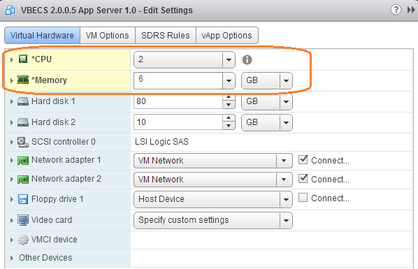

Turn the VM into a Template
- Right-click on the VM and choose Template, Convert to Template. Consult the VBECS 2.0.0 Virtual Machine Template Device Master Index to determine the name of the template.
- Continue with Appendix A: Update a Template, Step 12.

Customize the SQL Server

Prerequisite
These instructions are for customizing the SQL Server. If working on the App Server, go to Customize the App Server.
- Execute Steps 1 through 9 from Appendix A: Update a Template to turn the SQL Server template into a VM and note the IP address. After you have the IP, remote into the SQL Server using the local administrator account.

SQL Server Template Configuration
Follow these steps to configure Windows and software settings.

Disable User Access Control
- Click Start. In the search field, enter UAC.
- Click Change User Account Control Settings.
- Drag the slider down to Never notify. Click OK (Figure 12). Click Yes on the confirmation window that follows.
Figure 12: User Account Control Settings

Adjust the hard drive
- Open Administrative Tools, Disk Management.
- Right-click on the C: drive and choose Extend Volume.
- Click Next.
- Click Next.
- Click Finish. The C: drive will now have a capacity of 80 GB.

Configure IDs
- Open Administrative Tools, Computer Management.
- Expand Local Users and Groups and select the Users folder.
- Right-click on the apatosaurus ID and choose Delete.
- Right-click on the installer ID and choose Delete.
- Right-click on the Administrator ID and choose Rename.
- Rename the ID vaaacnimda and close Computer Management. From this point on, remember to log into the App Server Template with the vaaacnimda id instead of Administrator.

Enable Port 25
- Click Start, All Programs, McAfee, VirusScan Console.
- Double-click Access Protection.
- Select Anti-virus Standard Protection.
- Deselect Prevent mass-mailing worms from sending mail in both the Block and Report categories.

Update the Registry for Security Issues
- At the run prompt, type regedit and click OK.
- Navigate to HKEY_LOCAL_MACHINE\SYSTEM\CurrentControlSet\services\ac.sharedstore.
- Double-click on ImagePath.
- Put double quotes around the Value data so the entry looks like this: “C:\Program Files\Common Files\ActivIdentity\ac.sharedstore.exe”
- Click OK to save.
- Navigate to HKEY_LOCAL_MACHINE\SYSTEM\CurrentControlSet\Control\Session Manager.
- Right-click on Session Manager and select New, DWORD (32-bit) Value.
- Name the new value CWDIllegalInDllSearch.
- Right-click and select Modify.
- Enter 1 and click OK to save.

Rename and Adjust NICs
- Open Control Panel, Network and Internet, Network Connections.
- Rename adapter #1 GSS and adapter #2 Backup.
- Right-click on the Backup NIC and choose Properties.
- Uncheck everything except for IPv4 and IPv6. Click OK.
- Right-click on the Backup NIC and choose Properties, Configure, Advanced tab.
- There are four Checksum Offload properties, two for IPv4 and two for IPv6. Disable them all. Click OK to save.

Permissions
- Open Control Panel, System and Security, System.
- Click Change settings.
- Click Change.
- Enter VBECSSQLTMPLATE for the computer name.
- Select the domain radio button and enter vha.domain.ext. Click OK. Restart to join the domain.
- Navigate to Administrative Tools, Computer Management, Local Users and Groups, Groups.
- Open the local Administrators group.
- Add the HinesVbecsProdSqlSupport group.

Create a Validation Directory and Document to Record Screen Captures
- On the C: drive, create a folder named validation.
- In the validation folder, create subfolders named cluster and sql.
- The validation.rtf file is located at in VSS Dev, SQL 2012 Install. Copy it to the validation folder (Figure 13).
Figure 13: Validation Folders
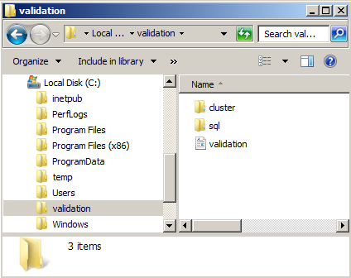

SQL Server Software Installation
Follow these configuration steps to install software.

Install and Configure SNMP
- Open Server Manager and click Features, Add Features.
- Select SNMP Services which will automatically select the two sub features. Click Next.
- Click Install.
- Click Close.
- Copy the \\\CDimages\_software\_VBECS 2.0\Both\SNMP scripts folder to C:\temp.
- Launch PowerShell (x64) by clicking the icon () in the Task Bar.
- Run the following command: “c:\temp\SNMP script\supdatesnmp”
- Close the PowerShell console.
- In c:\temp\SNMP scripts, double-click SNMP-config to run the registry edit.
- A warning will appear, click Yes followed by OK on the confirmation message.

Add .NET Framework Version 4.0
- The Version 4.0 framework is located on the \\\CDimages\_software\_VBECS 2.0\SQL Server\4.0 Framework share. Copy it to C:\temp and install.

Install Security Update for .NET Framework 3.5.1 (KB2898851)
- Copy the \\\CDimages\_software\_VBECS 2.0\Both\KB2898851 folder to C:\temp.
- Double-click on Windows6.0-KB2898851-x64 to start the installation.
- Click Yes to proceed with the installation.
- Click Close.

Install Security Update for .NET Framework 4.0 (KB2938780)
- Copy the \\\CDimages\_software\_VBECS 2.0\SQL Server\KB2938780 folder to C:\temp.
- Double-click on NPD40-KB2938780-x64 to start the installation.
- Click Next.
- Accept the license and click Next.
- Click Finish to complete the installation.

Apply Hotfixes
- The hotfixes are located on the \\\CDimages\_software\_VBECS 2.0\SQL Server\Hot Fixes share. Copy them to C:\temp\hotfixes (create this folder) and install. After installation is complete, reapply Windows Updates. Do not install any new version of Internet Explorer.

Apply AITC Fixes
- The hotfixes are located on the \\\CDimages\_software\_VBECS 2.0\SQL Server\AITC Updates share. Copy them to C:\temp\hotfixes and install. After installation is complete, reapply Windows Updates. Do not install any new versions of Internet Explorer.

Copy KB2645410
- Copy the \\\CDimages\_software\_VBECS 2.0\SQL Server\KB2645410 folder to C:\temp.

Copy SQL Server Installation Files
- The SQ n t llation files are located on the \\\CDimages\_software\SQL2012_Ent share. Copy the contents of the en_sql_server_2012_enterprise_edition_x86_x64_dvd_813294 folder to C:\temp\SQL 2012.

Copy Installation Support Files
- The installation support files are located in VSS Dev in the SQL 2012 Install folder. Copy the contents of the folder to C:\temp\SQL 2012.

Copy SQL Fixes
- The SQL fixes are located on the \\\CDimages\_software\_VBECS 2.0\SQL Server\SQL Fixes share. Copy the following file to C:\temp\SQL2012Updates.
- SQLServer2012SP2-KB2958429-x64-ENU

Install SCCM
- Copy the \\\CDImages\_software\_VBECS 2.0\Both\SCCM scripts folder to c:\temp.
- Double-click on IsolatedSystemClientInstall.bat (in the Client folder) to install SCCM. The installation takes about 30 seconds.
- From the command line, execute the following command: net stop ccmexec. You will see a message stating that the SMS Agent Host service has stopped successfully.
- Open Windows Services and set the SMS Agent Host service Startup type to Disabled.
- Click Start, Run. In the Run box, type MMC and press OK.
- Click File, Add/Remove Snap-in…
- Select Certificates and click Add.
- Select Computer account and click Next.
- Select Local Computer and click Finish.
- Click OK to close the Add or Remove window.
- Expand the Certificates, SMS. Delete both certificates.
- Close the console.

Adjust Memory and Central Processing Unit
- Shut down the virtual machine.
- In the vSphere Client, navigate to the VMs and Templates view.
- Right-click on the VM and click Edit Settings. Change the Memory Size to 32 GB (32768 MB). Click on CPU and change the CPUs to 4. Click OK to close (Figure 14).
Figure 14: Example of Virtual Machine Properties
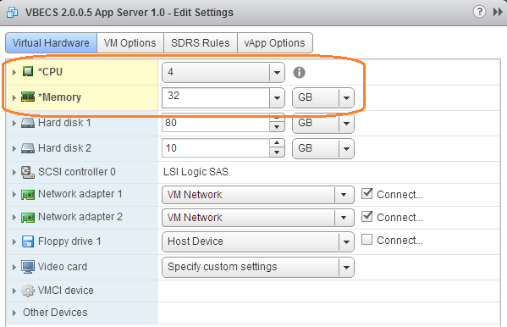

Turn the VM into a Template
- Right-click on the VM and choose Template, Convert to Template.
- Continue with Appendix A: Update a Template, Step 12.

Appendix A: Update a Template
These steps must be executed by a vSphere Administrator.
Prerequisites
- The server VM is online.

- Determine the name of the template by viewing the VBECS 2.0.0 Virtual Machine Template Device Master Index, Table 1.
- Open the vSphere console with administrative privileges and navigate to the VMs and Templates view. Right-click on the template that you wish to modify and select Convert to Virtual Machine (Figure 15).
Figure 15: Example of vSphere Web Client
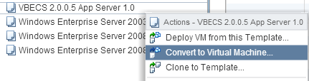
- Expand VBECSCluster and select IPADDRESS . Click Next (Figure 16).
Figure 16: Example of Convert Template to Virtual Machine
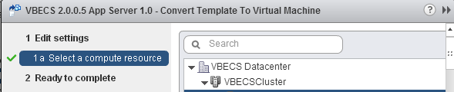
- Click Finish (Figure 17).
Figure 17: Example of Convert Template to Virtual Machine
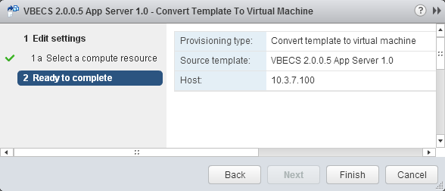
- If creating the template for the first time, execute Appendix B: Updating NIC and Hard Drive Settings.
- The template has now been turned into a server. Right-click the server and click Power On (Figure 18).
Figure 18: Example of vSphere Web Client
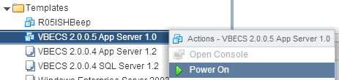
- Before you can remote into the VM, you must assign an IP address. Right-click on the VM and click Open Console (Figure 19).
Figure 19: Example of vSphere Client
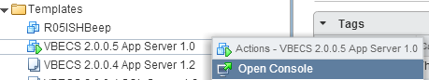
- The console window appears (Figure 20). Press Ctrl-Alt-Insert (not Delete) to login. Use the local administrator account.
Figure 20: Example of a Template
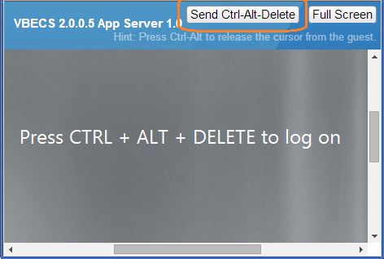
- Open a command prompt and type ipconfig. Note the IPv4 Address (Figure 21). If the server doesn’t have an IP address, assign one to Local Area Connection 2 in Control Panel. At this point, you can continue to use the console or establish a connection with the server via Remote Desktop. Accessing through the console is extremely slow, so accessing through RDC is recommended.
Figure 21: Example of Command Prompt
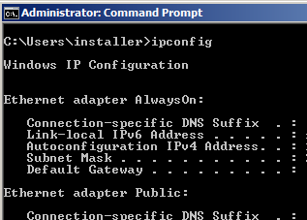
- Make any changes you need to make to the server. When done, shut down the server.
- Open the vSphere Console and right-click on server and click All vCenter Actions, Convert to Template (Figure 22).
Figure 22: Example of Convert to Template
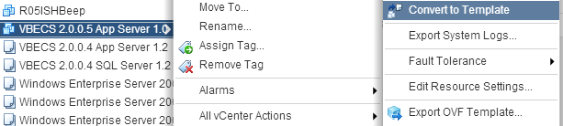
Note: The vSphere Web Client does not yet support all features that the traditional client does. To execute the rest of these steps, run the vSphere Client on .
- To export the template, select it and click File, Export, Export OVF Template (Figure 23).
Figure 23: Create a Template
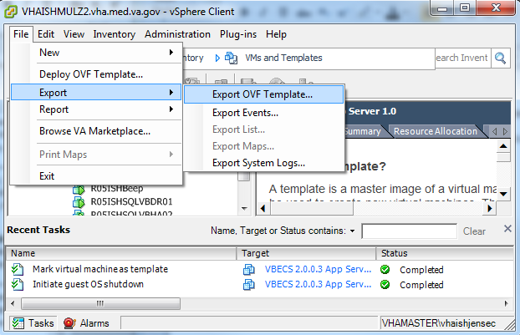
- Click the ellipsis and specify the E:\VBECS Virtual Machine Templates folder. Click OK (Figure 24). The template will then be exported.
Figure 24: Example of Export OVF Template
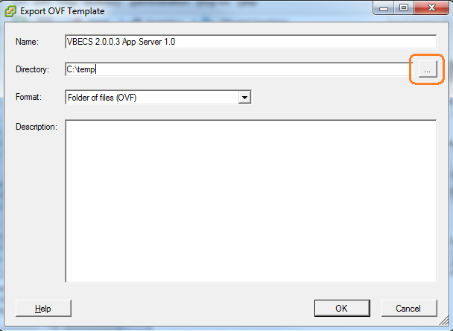
- If this was a template update, update the VBECS 2.0.0 Virtual Machine Template Tracking Log, following the steps in Error: Reference source not found.
This page intentionally left blank.

Appendix B: Updating NIC and Hard Drive Settings
These steps must be executed by a vSphere Administrator.
Prerequisites
- The server VM is online.

- Right-click on the template and select Edit Settings (Figure 25).
Figure 25: Edit Settings
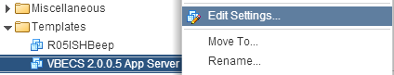

- In the Network adapter row, click the X to remove Network adapter 1 (Figure 26).
Figure 26: Remove Network Adapter
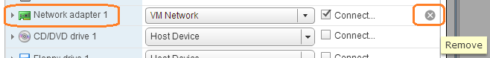

- Click Select and choose Network (Figure 27).
Figure 27: Network
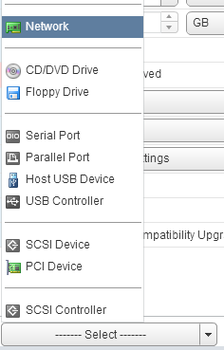

- Click Add twice to add two NICS. The screen will look like Figure 28 when done.
Figure 28: Two NICs
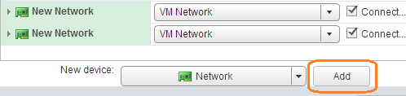

- Change the adapter type to VMXNET 3 for both adapters (Figure 29).
Figure 29: Adapter settings
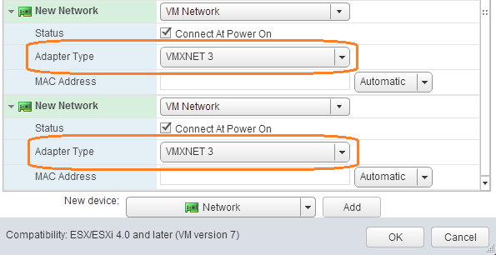

- Change the size of Hard disk 1 to 80 GB (Figure 30).
Figure 30: Hard disk 1
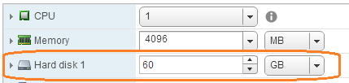

- In the CD/DVD drive row, click the X to remove the drive. Click OK to save changes.

This page intentionally left blank.

Index

A
Appendix A: Update a Template 29, 35
C
Create Server Templates from the Base Template 11
Create the Server Templates 11
Customize the App Server 15
Customize the SQL Server 24
I
Index 38
Introduction 9
P
Prerequisites 9
R
Revision History 3

This is the last page of VistA Blood Establishment Computer Software (VBECS) 2.0.0 Template Creation Guide.

